**Task2**

**Project: Student Database Management System (SQL)**

**1.Database Setup and 2. Data Entry:**

Insert 10 sample records into the "student_table" using INSERT command.

**Output of Database Creation**

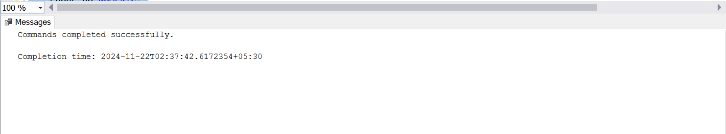

**Output of Table Creation**

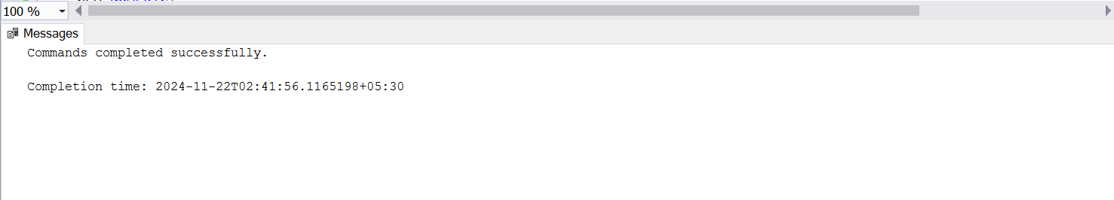

**Output of Insertion**

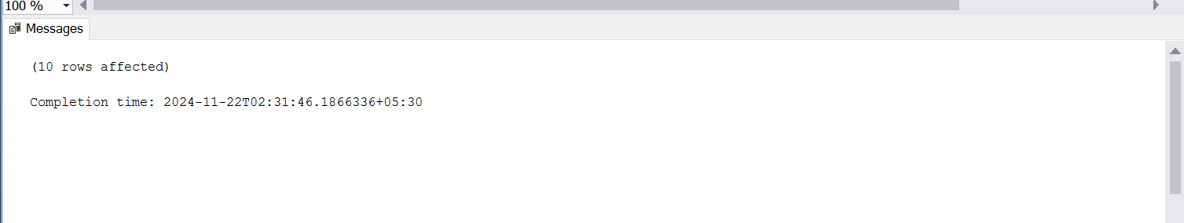

**3. Student Information Retrieval:**

Develop a query to retrieve all students' information from the "student_table" and sort them in descending order by their grade.

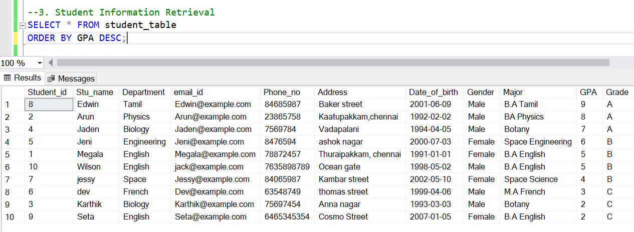

**4. Query for Male Students:**

Implement a query to retrieve information about all male students from the "student_table."

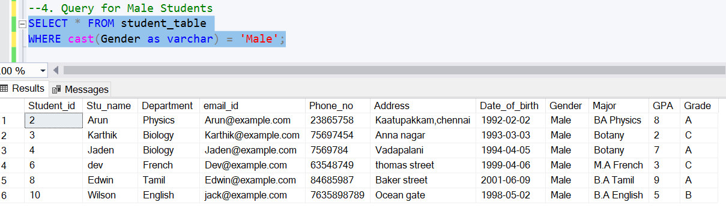

**5. Query for Students with GPA less than 5.0**

Create a query to fetch the details of students who have a GPA less than 5.0 from the "student_table.

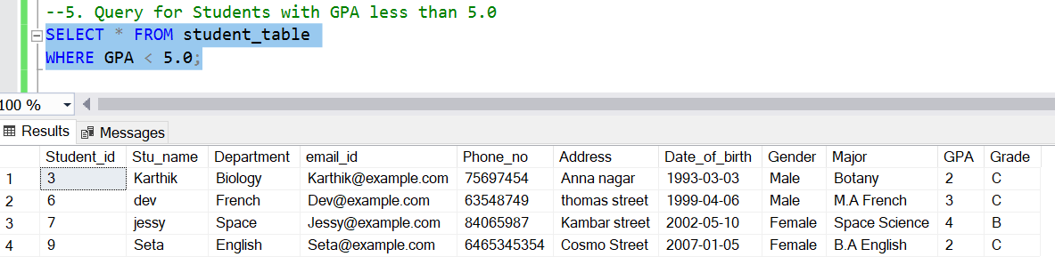

**6. Update Student Email and Grade**

Write an update statement to modify the email and grade of a student with a specific ID in the "student_table."

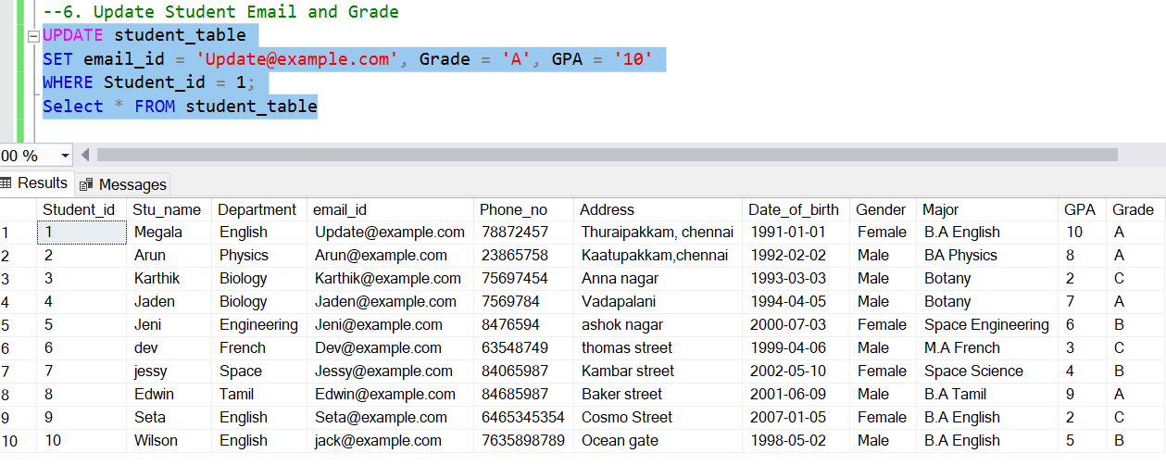

**7. Query for Students with Grade "B"**

Develop a query to retrieve the names and ages of all students who have a grade of "B" from the "student_table."

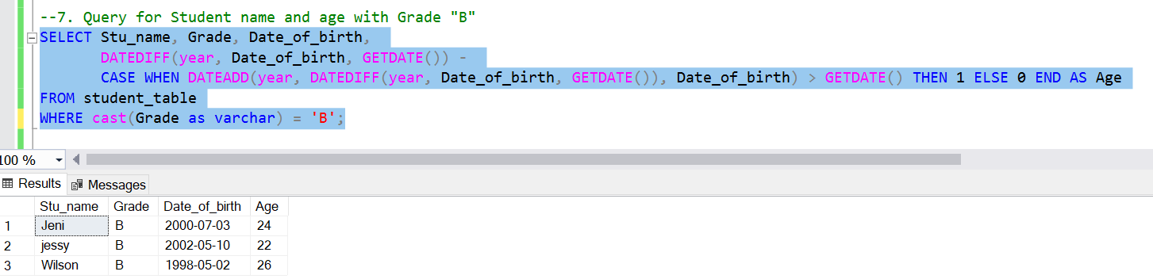

**8. Grouping and Calculation**

Create a query to group the "student_table" by the "Department" and "Gender" columns and calculate the average GPA for each combination.

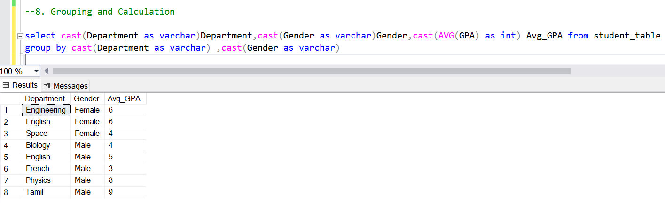

**9. Table Renaming**

Rename the "student_table" to "student_information" using the appropriate SQL statement.

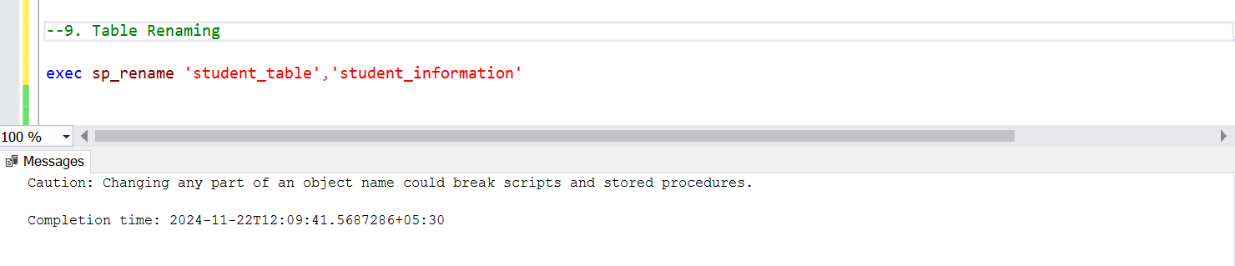

**Retrieving Table data after renaming**

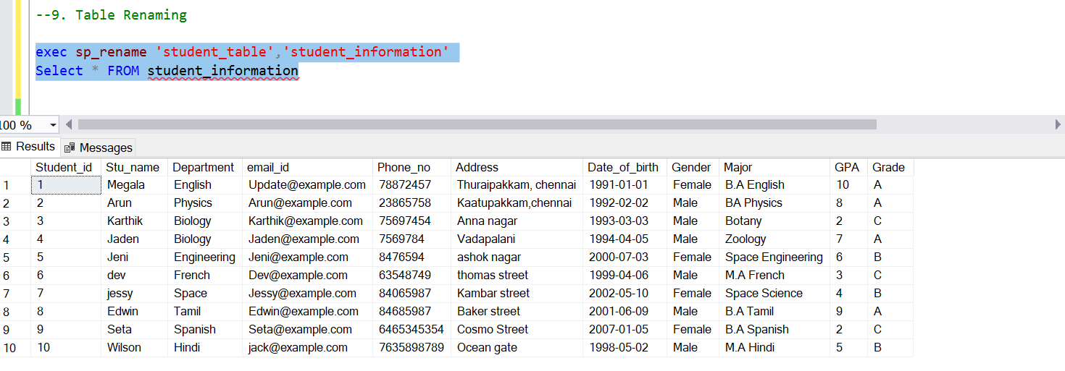

**10. Retrieve Student with Highest GPA**

Retrieve the name of the student with the highest GPA from the "student_information" table.

